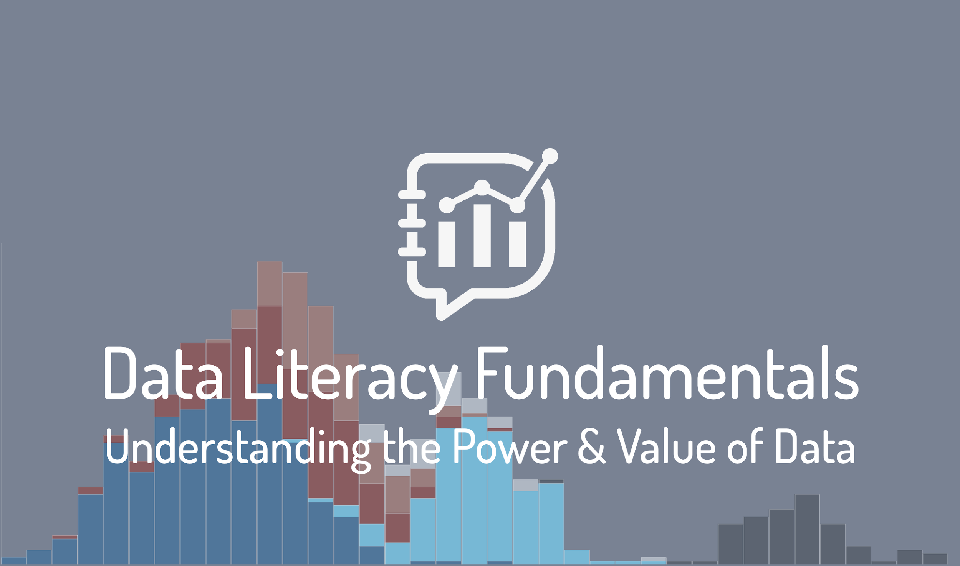

Lesson 1 Exercises

Lesson 1: The ONE Overall Goal of Data – Wisdom

Exercise 1.1
What's an area in either your personal or your professional life for which you want to use data to grow in wisdom? We'll use the answer to this question as the starting point for your course project.

Exercise 1.2
List three different sources of data that you have interacted with in the past week. They can come from any area of your life – professional, public, or personal.

Exercise 1.3
Pick one of the data sources from your list in Exercise 1.2. Write down at least one piece of information that you gleaned from this data, and how you needed to interpret it in order to turn it into information.
- Data:
- Information:
- How you interpreted the data to turn it into information:

Exercise 1.4
Take the information from Exercise 1.3 that you extracted from your chosen data source and ask yourself what knowledge you have gleaned from it. List any associations with other information or experiences that you needed to make in order to turn that information into knowledge.
- Knowledge gleaned:
- Helpful associations:

Exercise 1.5
Returning to the example you’ve been developing in the previous exercises, think of an unwise course of action and a wise course of action that could potentially stem from application of the knowledge your gleaned from your chosen data.
- A wise course of action to take:
- An unwise course of action to avoid:

