Lesson 1 Exercises

Lesson 1: Principles of Visual Data

Exercise 1.1a
Write down a list of three different graphical displays of data (e.g. charts, maps, dashboards) that you have interacted with in the past month. Let one of them be from your professional life, another from public life (your community, state, country or even global), and the last one from your own personal life. For now just write down a simple phrase or sentence that describes the source, like “fitness activity tracker” or “team performance dashboard.” We'll use the answer to this question as the starting point for your course project.
- Professional life:
- Public life:
- Personal life:

Exercise 1.1b
Look at the image below and answer the following two questions:
- How would you describe the appearance of the bar in the middle?
- What does the knowledge that the middle bar is actually a constant gray tell us about our visual system?

Exercise 1.2
Data can be collected about any situation, object, or activity. Look at the photograph below and identify at least one variable of each scale type in the scene.
- Nominal:
- Ordinal:
- Interval:
- Ratio:

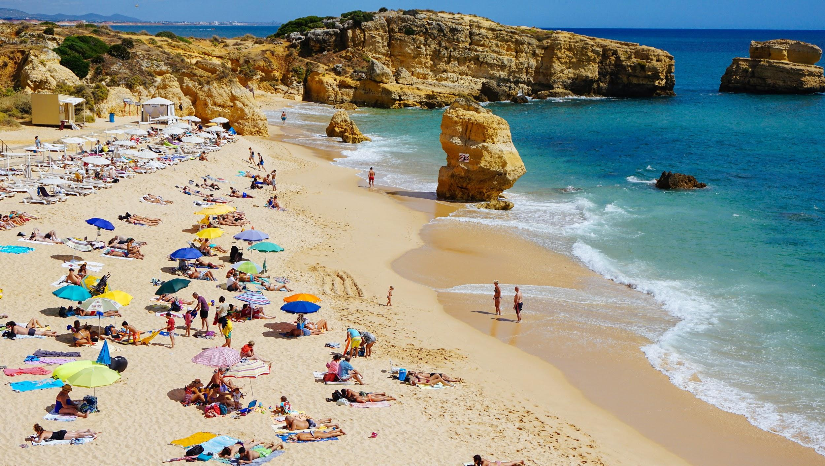
Photo by Dan Gold on Unsplash

Exercise 1.3
Look at the chart below (a chart called a Treemap that we’ll cover in Lesson 4) and identify the mark type and encoding channel used for the population variable.
- Mark type (points, circles, bars, or rectangles):
- Encoding channel (position, area, volume, tilt, or color):

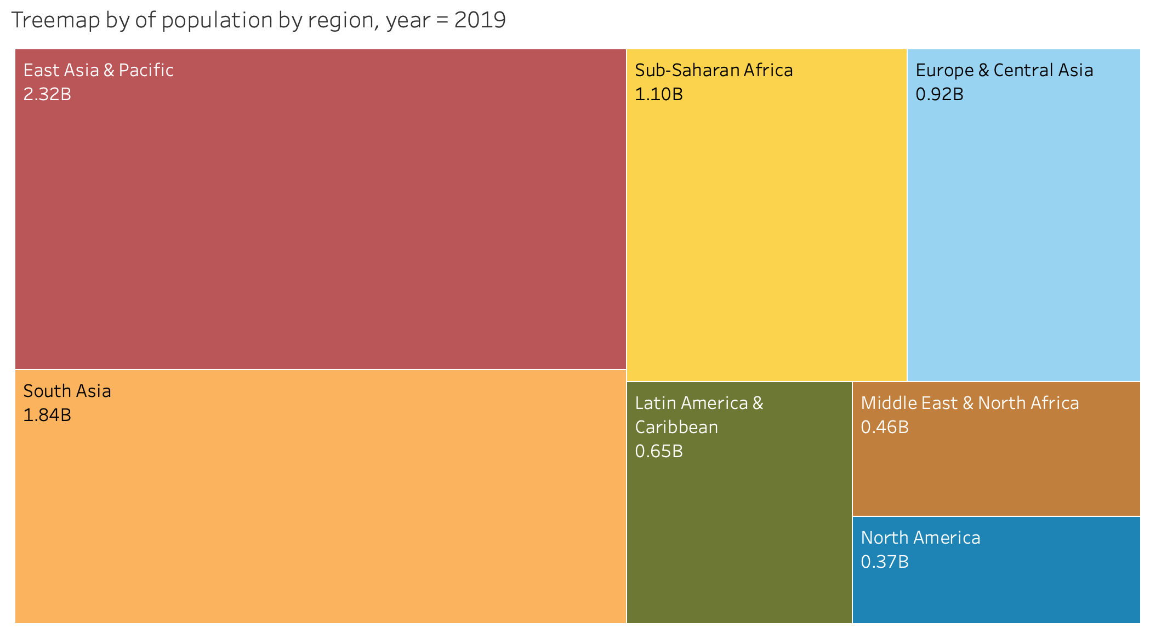

Exercise 1.4
Sketch marks that express the three (unordered) levels of the nominal variable on the left (eye color). Then sketch different marks that express the three (ordered) levels of the ordinal variable on the right (temp level).

Eye color (blue, brown, green) Temp level (cold, moderate, hot)

Exercise 1.5
The image below shows four different ways of encoding the exact same four quantitative values: bar length (top left), circle area (top right), pie slice angle (bottom left) and color saturation (bottom right). Note that the quantitative values are the 2019 populations of France, Germany, Mexico, and Brazil, respectively (as shown in the table below). Compare each of the charts to see how easy it is to confidently answer the following questions:
- Which is bigger, B or A?
- How much bigger is C than A?
- Is D bigger than the combined values of A, B, and C?
- If A has a value of 1, what do you estimate is the value for D?

Symbol | Country | 2019 Population | Normalized to A | Normalized to D
A | France | 67,059,887 | 1 | 0.32
B | Germany | 83,132,799 | 1.24 | 0.39
C | Mexico | 127,575,529 | 1.90 | 0.60
D | Brazil | 211,049,527 | 3.15 | 1

